Phase 2 – Hypothesis generation with increasing N

Main issues
What is the best way to collect, organize, and present data?
How can we validate the hypotheses formulated in the previous phase?
How can we collect more data to increase our confidence in the hypotheses?
How can we use relative frequencies and percentages to analyze data?
How can we calculate the fraction of a number to estimate the number of items of each type in the bottle? If out of 100 rolls, X are of one color, in a bottle with M balls, how many balls will I have of that color? If out of 150 rolls, 71 are of one color, in a bottle with 25 balls, how many balls will I have of that color?
How can we interpret the decimals obtained in the calculations? How can it be that we have 0.75 balls?
How can we determine the level of confidence in our hypotheses?
Objectives
Validate the hypotheses formulated in the previous phase through data collection and analysis.
- Learn more about the data collection and analysis process.
- Learn to organize and present data in a clear and concise way (tables, graphs, etc.).
- Introduce the concept of relative frequency and its relationship with percentage.
- Develop strategies to validate hypotheses based on the data collected.
- Reflect on the level of confidence in the hypotheses and how this is affected by the sample size.

Phase structure: main moments, timing and classroom dynamics

[1] Segona recollida de dades amb N creixent 30 minutes (Session 2)

Continuing with the dynamics of the previous session, the teacher will recall the question How is a (statistical) study organized? and What is the best way to collect, organize and present data? The teacher will remind the students that they will have to collect data and they will have to explore which strategies work best for them to organize this collection. If they do not do it naturally, the teacher should guide the teams to look for more efficient ways.

He will indicate that they will have time to collect data again, this time systematically , since not all teams were able to do so in the previous session. The teacher will ask that after the established time, each team must share how many times they have seen each color and a feasible hypothesis based on this collection about the composition of the bottle.

In the dossier [Phase 2 – Report] they have a space to collect the data. Here it is expected that they can build a table, diagram or make a calculation and that the idea of percentage begins to emerge with the question If out of 100 draws, X are of one color, in a bottle with M balls, how many balls will I have of that color?

It might be interesting to see if a team collects the data in groups of 25, as the frequencies would directly match the composition hypothesis. But they could also do groups of 100 and relate it to percentages.
At this first stage, we let them explore different ways of deciding sample sizes, techniques for generating hypotheses from the data and discussing their level of confidence.

[2] Posada en comú de les respostes 10 minutes (Session 2)
The teacher writes each team's answer on the board (Figures 1 and 2) . At this point, it can be seen which is the best way to express the answer. Here we can make a table where the first column is the team/bottle number and on the right we write the number of balls of each color that each team proposes.
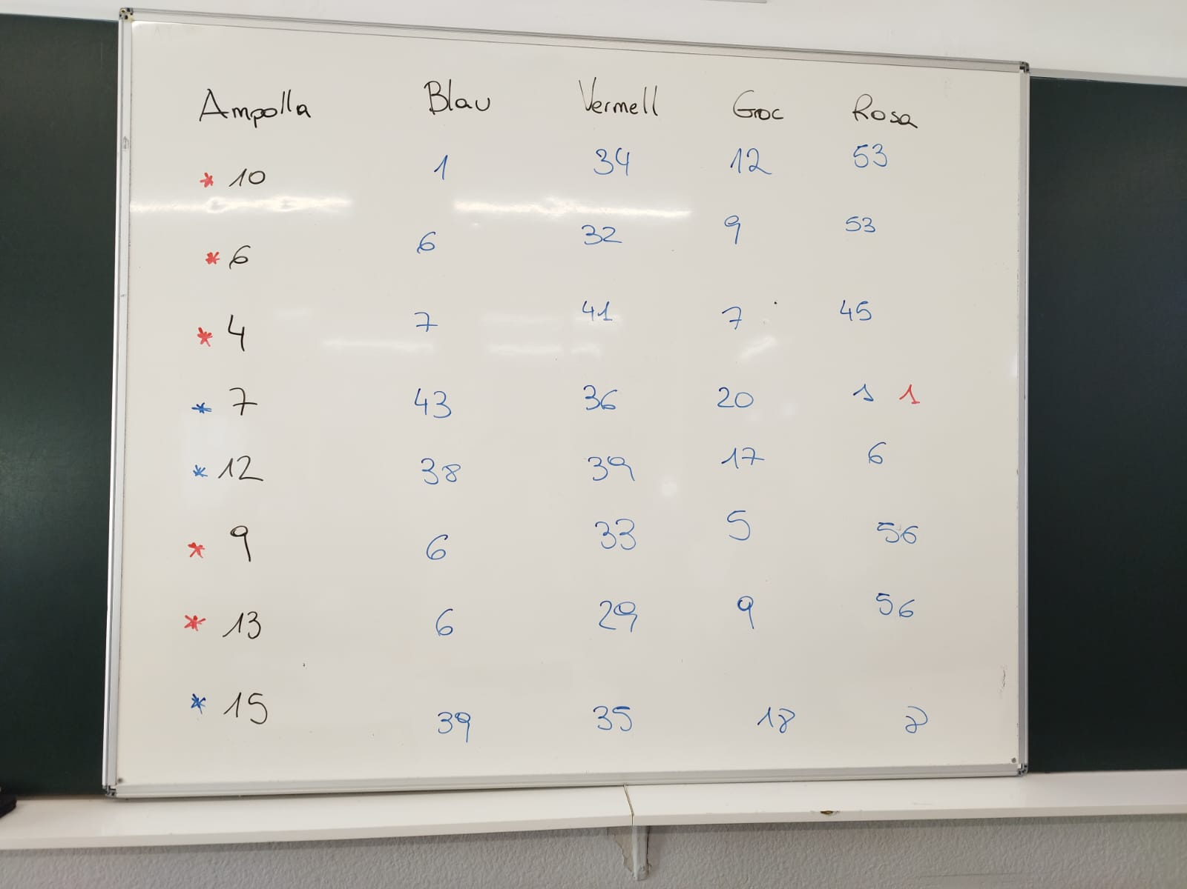
Figure 1 : Example of sharing frequencies
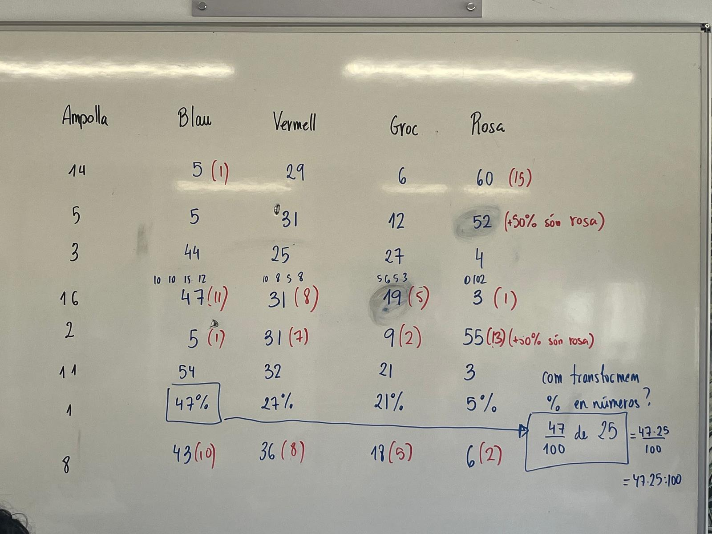
Figure 2 : Example of sharing on the board with absolute frequencies in blue and hypotheses in red
We hope that some team will comment that these frequencies can be interpreted as percentages, since they have made 100 visualizations. This idea of percentage can be linked to the idea of fraction and ask: If 47% of the visualizations we have seen a blue ball, out of the 25 total balls, how many blue ones do we expect there to be? In this case the teacher will guide the class to remember the concept of fraction of a number , he can use as an example the situation: How many minutes are ¾ of 60 minutes? Or How many students are 2/3 of 30 students? Finally he will guide the calculation, which will surely be a number with decimals:
$$\frac{47}{100}de 25=\frac{47·25}{100}=11,75$$
The teacher will also ask about the meaning of these decimals: How is it possible that we have 0.75 balls? In this case, the teacher will reflect that these decimals appear because the division is not exact and is normal, because we can have frequencies that do not contain all the divisors of 100. But we interpret this result thinking that we will have to perform some rounding to approximate this calculation to a realistic value.
We can also discuss what the numbers should be like so that the results are increasingly closer to unity and what we can do experimentally to make these decimals tend towards natural numbers.

[3] Generació d’hipòtesis 10 minutes (End of session 2)

The teacher will ask students to use the notions of fractions and percentages to generate a hypothesis consistent with the data collected and be able to give a hypothesis.
It is also important at this point to ask each team about their level of confidence ( How confident are we of the results? ) and to emphasize that this may be key information to write in the conclusions of the report. If the teacher considers it appropriate, another column can also be added indicating the level of confidence that the team estimates it has about its hypothesis. We hope that the students can be fairly confident in their hypothesis, but never completely.
Here the students will have to see that the larger the sample size, the greater the degree of confidence we will have. The teacher will indicate that this is precisely what they will study during the next session.

[4] Nova recollida de dades amb N creixent 30 minutes (Session 3)
The teacher will begin the session by recording on the board the hypotheses about the composition of the bottle from the different teams.
The teacher will indicate that the same experiment will be carried out again in order to have more information about the bottle (more data), thus increasing their level of confidence in the different hypotheses.
The teacher will indicate that they will have to collect data again, but this time they will consider a sample size of N=150 visualizations. The teacher will indicate that they can reuse the data from the previous day, therefore, they will only need to do 50 new visualizations and accumulate the results.
The teacher will distribute a new sheet [Phase 2 – Report] where they will have to re-record the data and generate a new hypothesis.
The teacher will now write the new hypotheses on the board (Figure 3), in a different color, next to the original hypotheses and a debate will be opened on which bottles resemble each other.
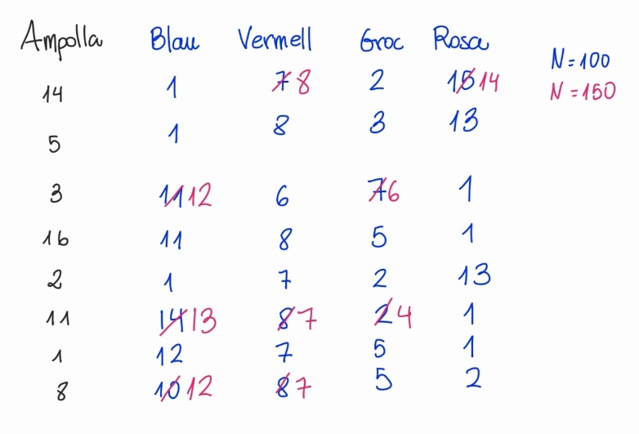
Figure 3 : Image of the blackboard with the sharing of the different hypotheses
Optionally, this process can be repeated with N = 200 or 300 views.
Here we hope that the hypotheses will become more and more similar and it will be natural to reach the conclusion that there are only two types of bottles: those with more blue and those with more pink. In the same way, it will become clearer that when we increase the sample size, there is less variability between the data.
In this case it is natural that the question arises If out of 150 rolls, 71 are of one color, in a bottle with 25 balls, how many balls will I have of that color? , the teacher will have to remember the procedure done previously when they had the concept of percentage, but now with a denominator other than 100:
$$\frac{71}{150}de 25=\frac{71·25}{150}≈11,83$$

Resources and materials needed/available
Different bottles : The same distribution as in the previous phase.
The Phase 2 report – Report
Phase2 report – Final report
Class board : Where the teacher will have to write a table with a summary of the hypotheses and results.

Relevant comments for Phase management
Resisting...
Although it may seem that students are more accepting of the idea of using the rule of three , we avoid introducing it, as it leads to very mechanized justifications that do not encourage reasoning.

